Appsters Industry Page Layout
HEALTHCARE
Laid out fold by fold against www.appsters.io/industry
 | DETAIL
Slug | healthcare-app-development-services
Meta Title | Healthcare App Development Company | HIPAA Compliant Apps
Meta Description | Need a HIPAA compliant health app? Appsters builds telehealth, EHR integrated and patient engagement platforms. Book a free consultation with our team.
Layout Source | www.appsters.io/industry
Live Folds | 23
New Blocks Required | 3

FOLD 1: Hero Banner
Hero Banner
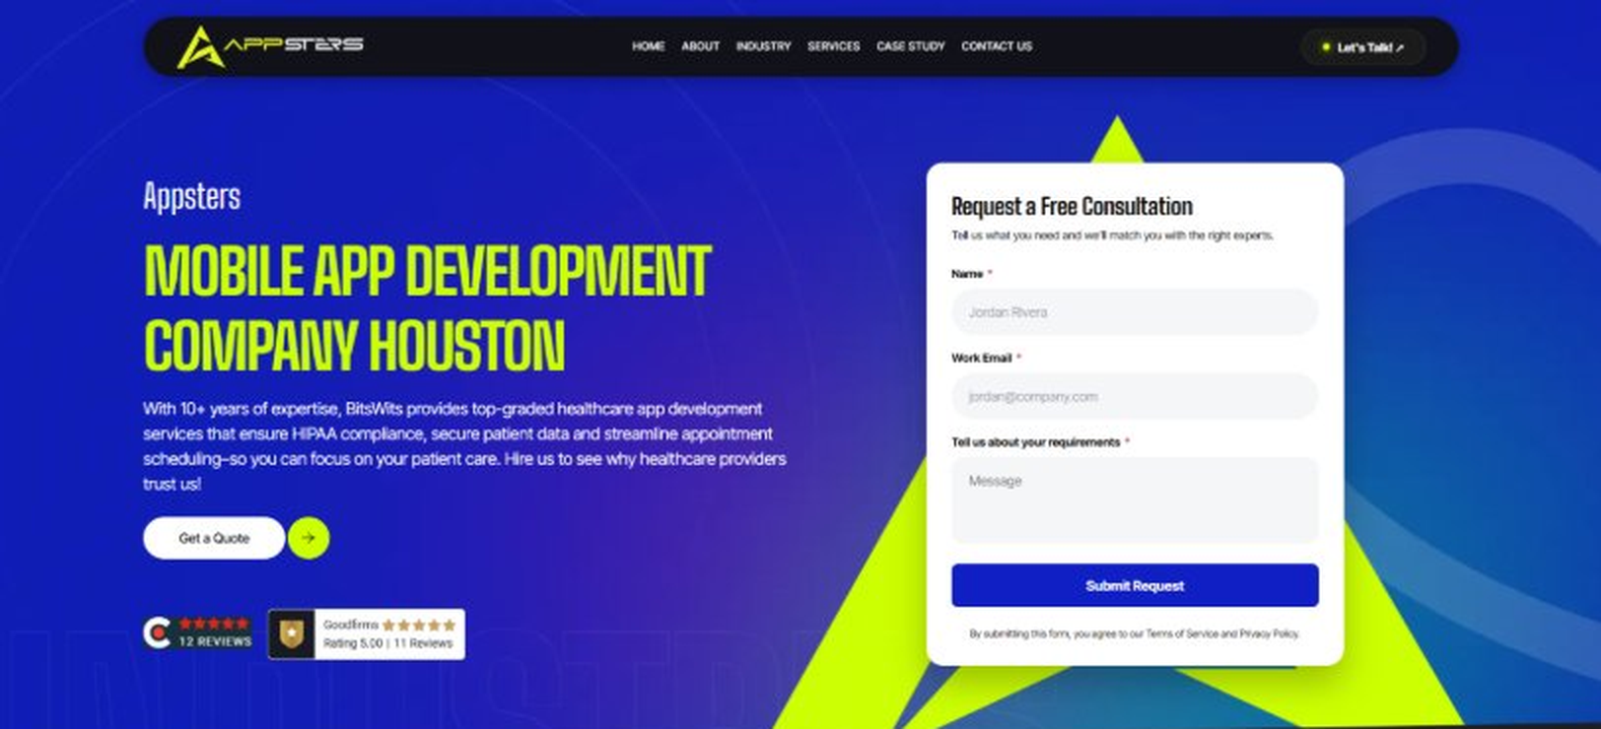
Current live page, www.appsters.io/industry
 | DETAIL
Status | New copy applied
Build Notes | Live block holds H1, sub copy, a Get a Quote button and the Request a Free Consultation form. New copy supplies the H1 and sub copy only.
QA Flag | Live hero copy currently names BitsWits and describes healthcare services. Leftover copy from another build, replace it with the new copy below.
Copy For This Fold
PAGE ELEMENT | COPY (WORD FOR WORD)
H1 (Page Heading) | A Healthcare App Development Company Building Platforms Doctors And Patients Actually Trust
Body Copy | Care decisions can't wait on a slow app. Appsters operates as both a healthcare app development company and a healthcare mobile app development company trusted by hospitals, clinics, and health tech startups across the country. We build platforms that keep doctors, patients, and care teams connected through secure, dependable technology built to survive a real audit, not just a demo.
FOLD 2: Marquee Strip
Marquee Strip: Turn Your Wildest Ideas Into Powerful Digital Products
Current live page, www.appsters.io/industry
 | DETAIL
Status | No copy change
Build Notes | No new copy in the source document for this fold. Keep the live block exactly as it is.
FOLD 3: Stats Counter
Stats Counter: Work With A Local Mobile App Developer In Houston
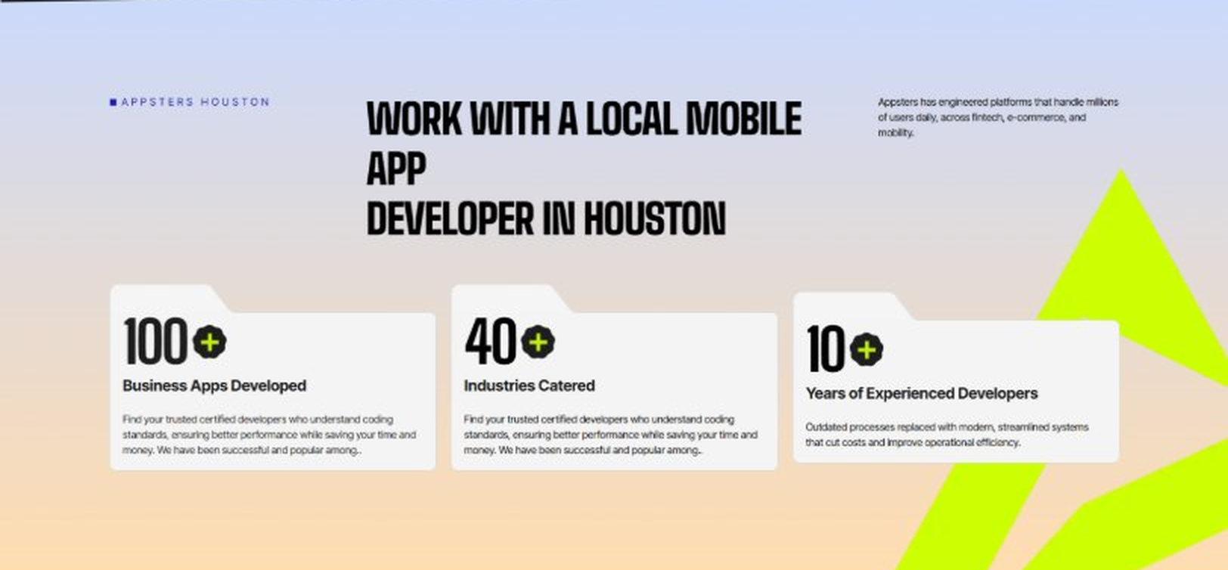
Current live page, www.appsters.io/industry
 | DETAIL
Status | New copy applied
Build Notes | Live block holds 3 counters. New copy holds 6 stats. Either widen the block to 6 or drop two.
Copy For This Fold
PAGE ELEMENT | COPY (WORD FOR WORD)
H2 (Section Heading) | Awarded For Building Healthcare Apps That Meet Real Clinical Standards
Body Copy | Our mobile health app development work has earned recognition for compliance rigor, data security, and measurable patient engagement gains. Appsters has been recognized for delivering platforms that protect sensitive data, integrate with clinical systems cleanly, and stay reliable during high-demand periods like flu season or a public health event. Every award reflects tested performance, not a marketing claim.
Stat 1 Number | 40+
Stat 1 Label | Industries Served
Stat 1 Copy | Our experience spans social platforms, marketplaces, fintech, healthcare, and more, with solutions adapted to each sector's demands for security, AI, compliance, and user adoption.
Stat 2 Number | 3000+
Stat 2 Label | Apps and Solutions Delivered
Stat 2 Copy | Thousands of projects executed with an emphasis on speed, AI adoption, stability, and clear ROI across both startup and enterprise environments.
Stat 3 Number | 60+
Stat 3 Label | AI Models Deployed
Stat 3 Copy | Every model is designed for high accuracy, reliable outputs, and performance at scale for mission-critical workflows and more.
Stat 4 Number | 50,000+
Stat 4 Label | Legacy Processes Modernized
Stat 4 Copy | Outdated processes replaced with modern, streamlined systems that cut costs and improve operational efficiency.
Stat 5 Number | 250+
Stat 5 Label | Engineers and Designers
Stat 5 Copy | A global team skilled in native mobile app development, AI-driven ecosystems, cross-platform builds, and enterprise architecture.
Stat 6 Number | 95%
Stat 6 Label | Client Retention
Stat 6 Copy | Long-term partnerships built on trust, consistent delivery, and continuous optimization of live applications.
FOLD 4: Marquee Strip
Marquee Strip: Mobile App Development Services
Current live page, www.appsters.io/industry
 | DETAIL
Status | No copy change
Build Notes | No new copy in the source document for this fold. Keep the live block exactly as it is.
FOLD 5: Services Grid
Services Grid: Our Comprehensive Mobile App Development Services In Houston
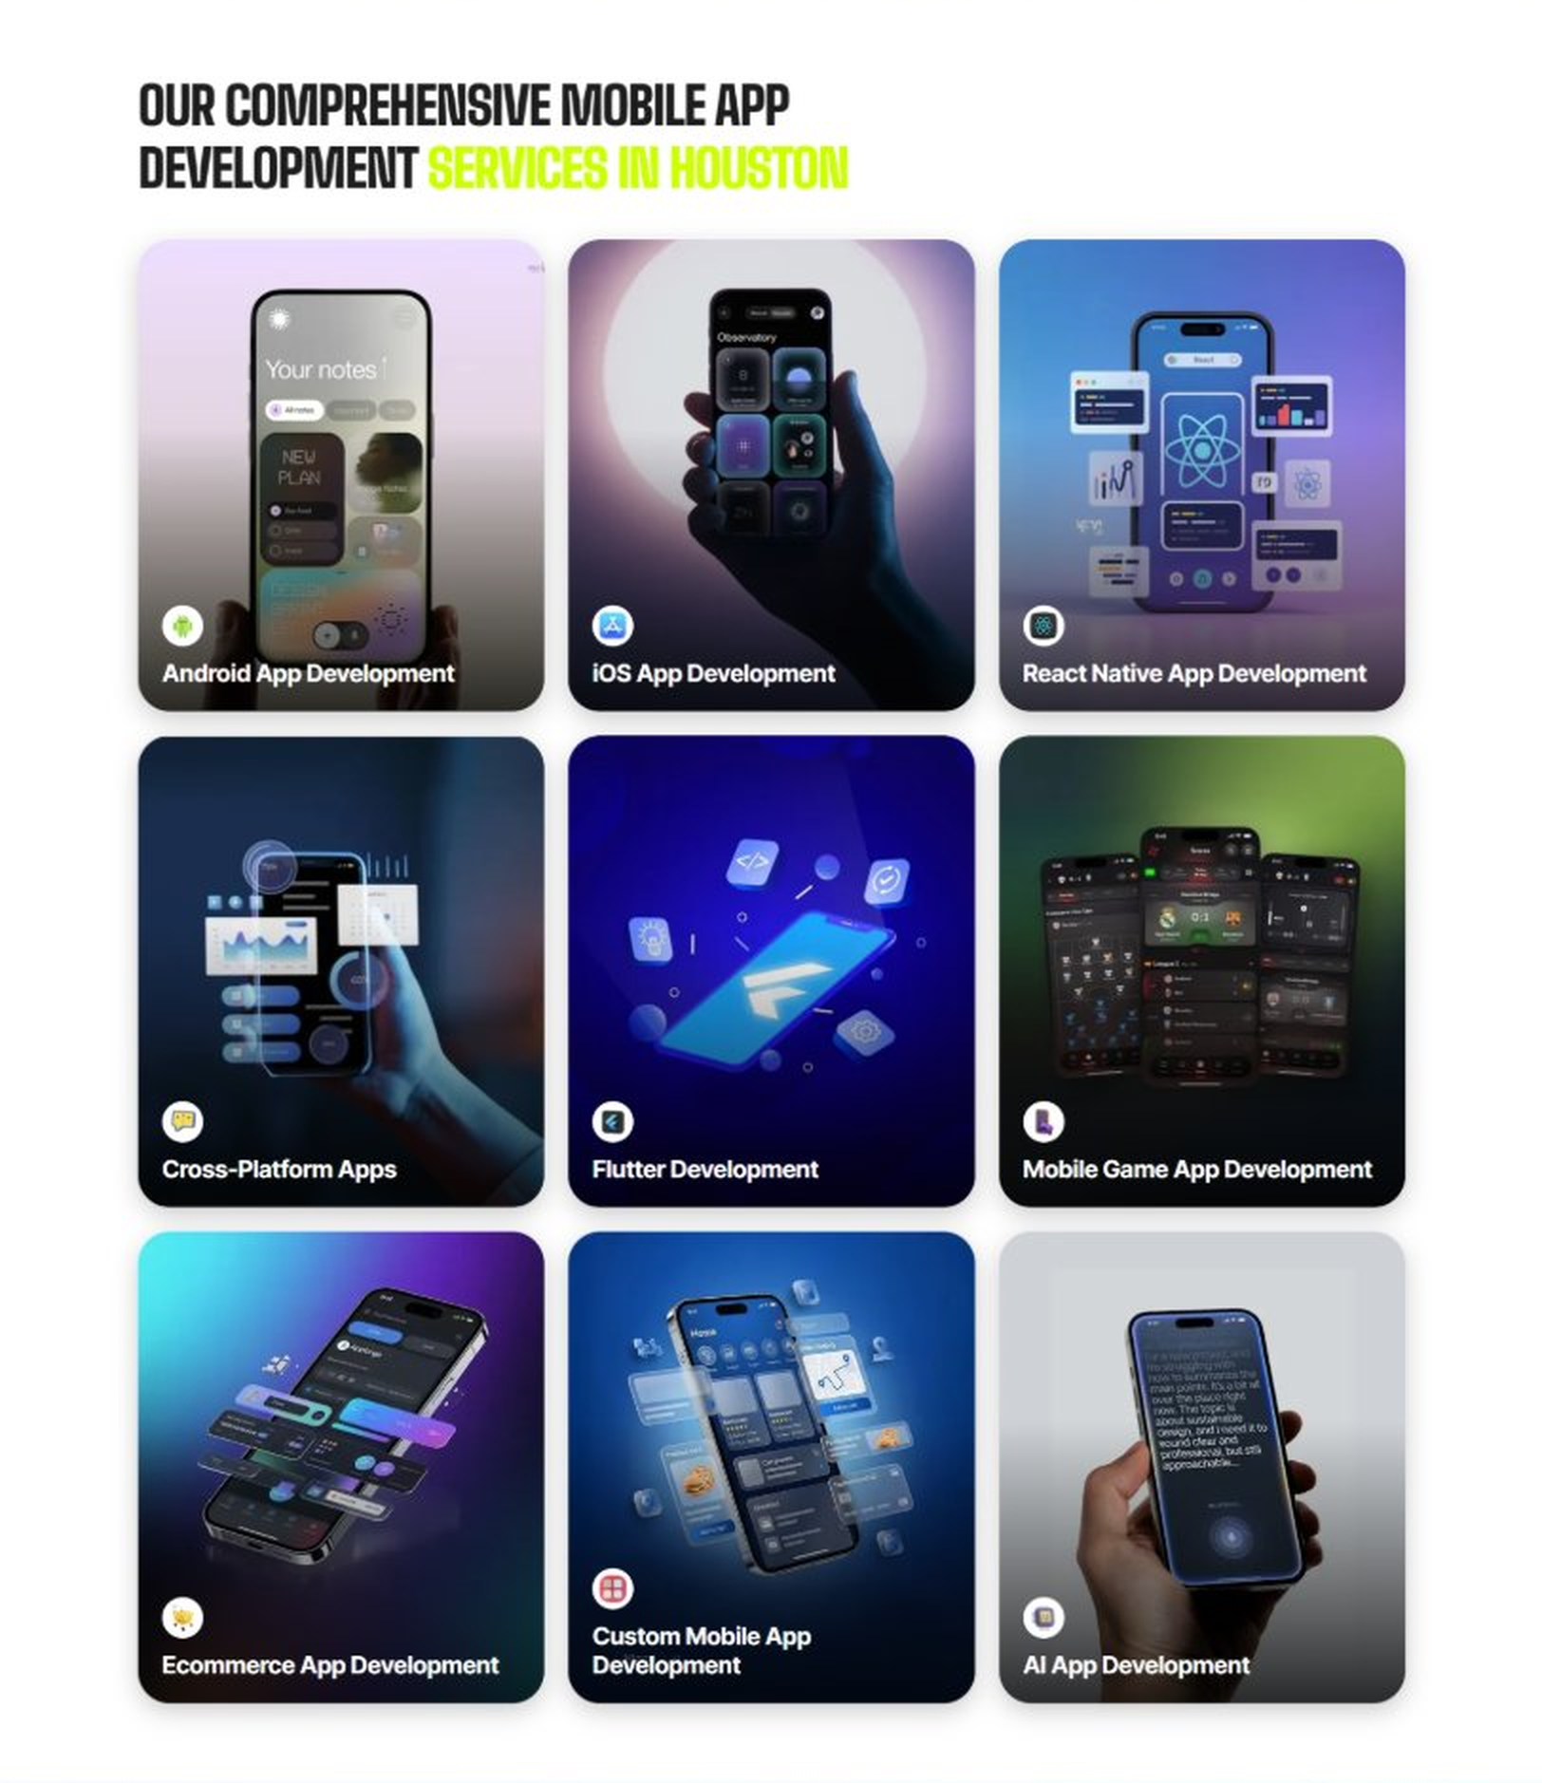
Current live page, www.appsters.io/industry
 | DETAIL
Status | New copy applied
Build Notes | Live grid holds 9 cards. New copy holds 5 services. Either trim the grid to 5 or brief four more services.
Copy For This Fold
PAGE ELEMENT | COPY (WORD FOR WORD)
H2 (Section Heading) | Healthcare Application Development Services Built For Real Clinical Workflows
Body Copy | Strong healthcare platforms sit at the crossroads of compliance, clinical workflow, and patient experience. As a healthcare app development company, we connect medical app development expertise with technical precision, building wellness apps and clinical tools that actually fit how care teams work day to day.
Service 1 Heading | Health Mobile App Consulting
Service 1 Copy | Our healthcare app developers start with a deep audit of your existing workflow before writing a single line of code, so the product we design solves the actual bottleneck instead of a guessed one.
Service 2 Heading | Health App Upgrade & Modernization
Service 2 Copy | We take an outdated health care mobile application and rebuild it around modern security standards, better performance, and an interface clinicians and patients don't need training to use.
Service 3 Heading | Patient Engagement Applications
Service 3 Copy | Our medical apps for patients focus on the moments that actually affect outcomes: appointment reminders, medication tracking, and secure messaging with care teams, without overwhelming patients with features they'll never open.
Service 4 Heading | Fitness And Exercise Mobile Apps
Service 4 Copy | As a fitness app development company, we build activity tracking and wellness coaching tools that integrate with wearables and clinical data where appropriate, connecting daily habits to real health outcomes.
Service 5 Heading | Telehealth Mobile Apps
Service 5 Copy | Our telehealth mobile app development covers secure video consultations, e-prescriptions, and care coordination, built to hold up under the same connectivity conditions patients actually have at home.
FOLD 6: Case Study CTA
Case Study CTA: HELPP
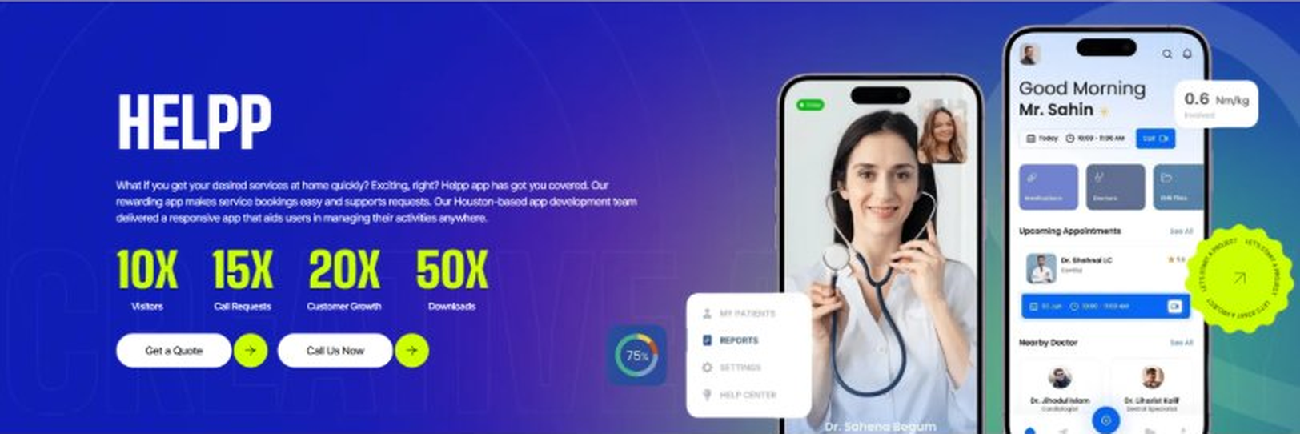
Current live page, www.appsters.io/industry
 | DETAIL
Status | New copy applied
Build Notes | Live block holds a product name, a paragraph, four metric counters and two CTA buttons. New copy supplies the heading and paragraph. Metrics still need to be supplied.
Copy For This Fold
PAGE ELEMENT | COPY (WORD FOR WORD)
H2 (Section Heading) | Healthcare Mobile App Development Built On Compliance From Day One
Body Copy | Building a health app is easy. Building HIPAA-compliant apps that survive an actual security audit is the hard part. If you're ready to build a healthcare platform that protects patient data and passes real scrutiny, Appsters is the partner that gets you there. Let's talk about your compliance requirements and your patients' actual needs.
FOLD 7: Testimonials
Testimonials: Real Stories From People Who Wanted What’s Next
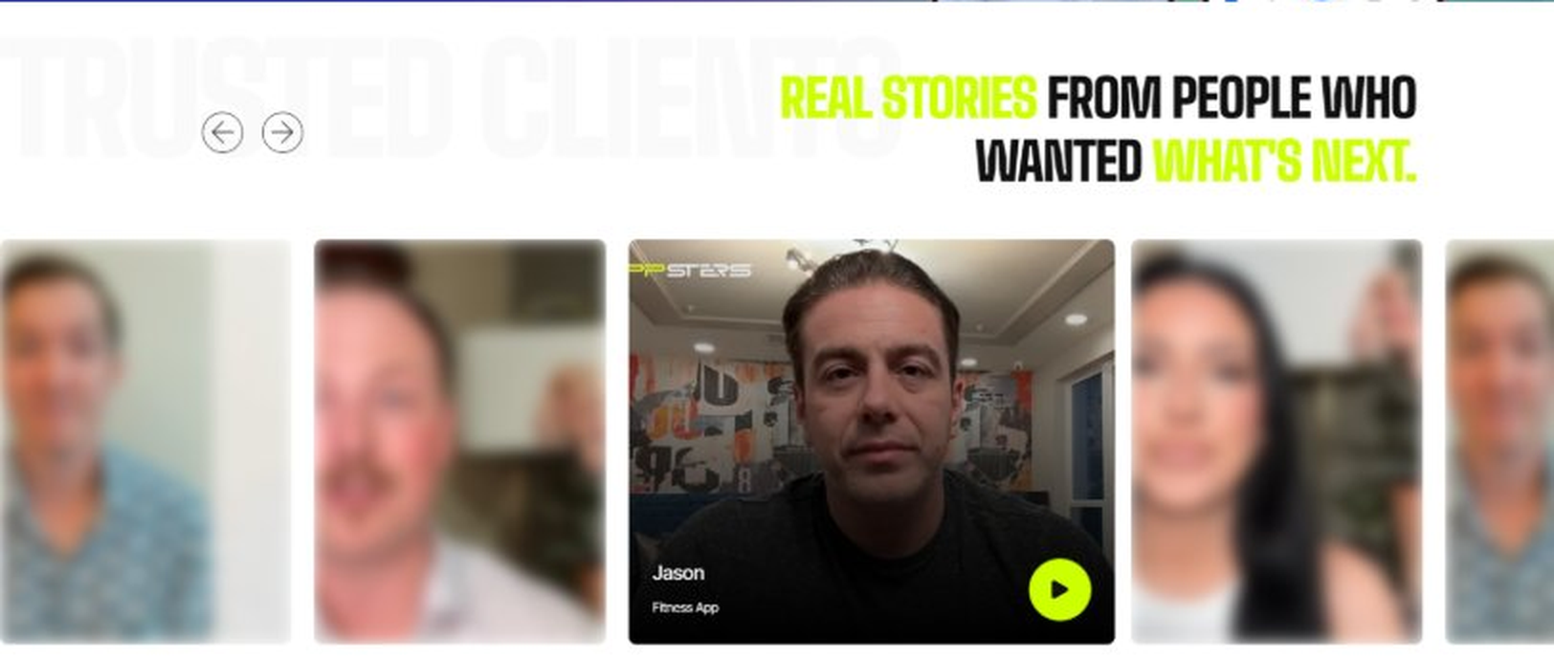
Current live page, www.appsters.io/industry
 | DETAIL
Status | New copy applied
Build Notes | Live block runs video testimonials. New copy is written quotes with attributions. Source document marks this fold design TBD.
Copy For This Fold
PAGE ELEMENT | COPY (WORD FOR WORD)
H2 (Section Heading) | What Our Clients Say
Testimonial 1 Quote | "We'd failed a security audit with our previous vendor's app, which is not a fun call to get. Appsters rebuilt it with compliance as the starting point instead of an afterthought, and our next audit was actually uneventful."
Testimonial 1 Attribution | Dr. Sandra Whitfield, Chief Medical Information Officer
Testimonial 2 Quote | “Our nurses were drowning in redundant data entry before this. That's mostly gone now, and I genuinely didn't expect the adoption to happen this fast among staff who usually resist new software."
Testimonial 2 Attribution | Michael Torrance, Director of Clinical Operations
Testimonial 3 Quote | "Telehealth visits used to drop calls constantly on our old platform, which is a terrible thing to have happen during an actual appointment. That problem disappeared with the new build."
Testimonial 3 Attribution | Dr. Amara Osei, Family Medicine Physician
Testimonial 4 Quote | “I've sat through a lot of vendor pitches that treated HIPAA as a slide in a deck. Appsters treated it as the actual foundation of the build, which is the only way this should be done."
Testimonial 4 Attribution | Karen Delacroix, Compliance Officer
Testimonial 5 Quote | "What stood out was how the wearable integration just worked on the first try. I've seen that go badly with other vendors more than once."
Testimonial 5 Attribution | Dr. Owen Trask, Cardiology Department Head
Source document note: Testimonial fold, design TBD after content
FOLD 8: Technology Logo Strip
Technology Logo Strip

Current live page, www.appsters.io/industry
 | DETAIL
Status | No copy change
Build Notes | No new copy in the source document for this fold. Keep the live block exactly as it is.
FOLD 9: Why Choose Us
Why Choose Us: Compelling Reasons To Choose Us As A Trustable App Development Company In Houston
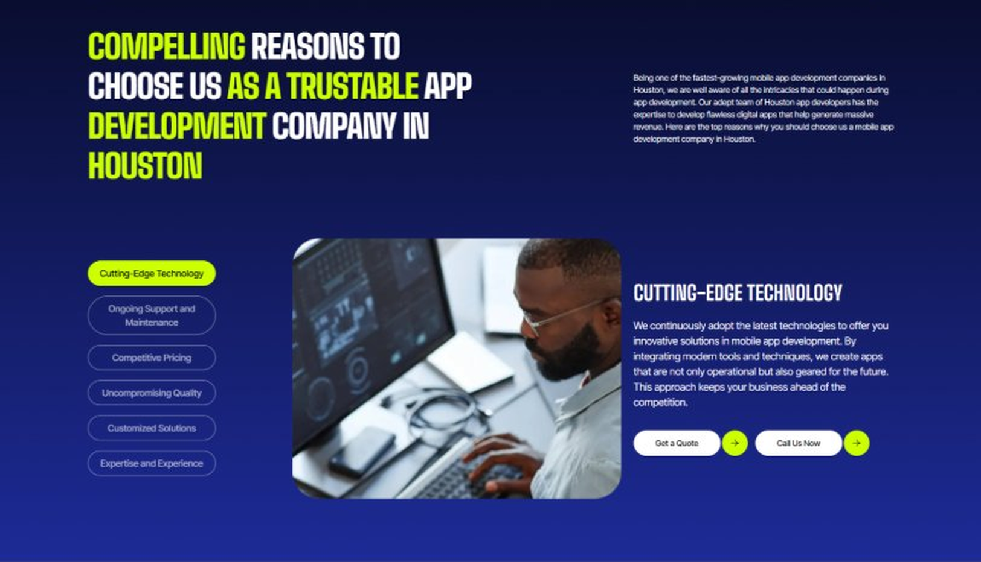
Current live page, www.appsters.io/industry
 | DETAIL
Status | New copy applied
Build Notes | Live block holds 6 tabs. New copy holds 6 reasons. Clean one to one fit, no design change needed.
Copy For This Fold
PAGE ELEMENT | COPY (WORD FOR WORD)
H2 (Section Heading) | Why Providers Choose Appsters As Their Trusted Healthcare App Partner
Body Copy | Choosing a healthcare app development partner shapes whether your platform earns clinical trust or gets abandoned after the first compliance concern. Our team blends clinical workflow knowledge, engineering discipline, and regulatory expertise to build apps providers actually rely on.
Reason 1 Heading | Compliance-First Architecture
Reason 1 Copy | We design every feature around HIPAA and data security requirements, backed by real audit experience rather than assumptions.
Reason 2 Heading | Built-In Clinical Logic
Reason 2 Copy | Care workflows aren't bolted on later. Our systems are designed around how clinicians actually work from the first wireframe.
Reason 3 Heading | Peak-Demand Engineering
Reason 3 Copy | Our architecture is stress-tested for high-demand periods, so a surge in patient volume becomes a manageable event, not an outage.
Reason 4 Heading | Interoperability Depth
Reason 4 Copy | From FHIR to HL7, we have real experience connecting to the clinical systems that already exist in most healthcare organizations.
Reason 5 Heading | Transparent Development Cycles
Reason 5 Copy | We follow sprint cadences with review checkpoints and shared roadmaps, so clients always know what's shipping and what's improving.
Reason 6 Heading | Long-Term Platform Thinking
Reason 6 Copy | We structure apps as ecosystems that evolve with new regulations and care models, built for longevity rather than a single launch cycle.
FOLD 10: Sector Tabs
Sector Tabs: Serving 40+ Sectors With Mobile App Development In Houston
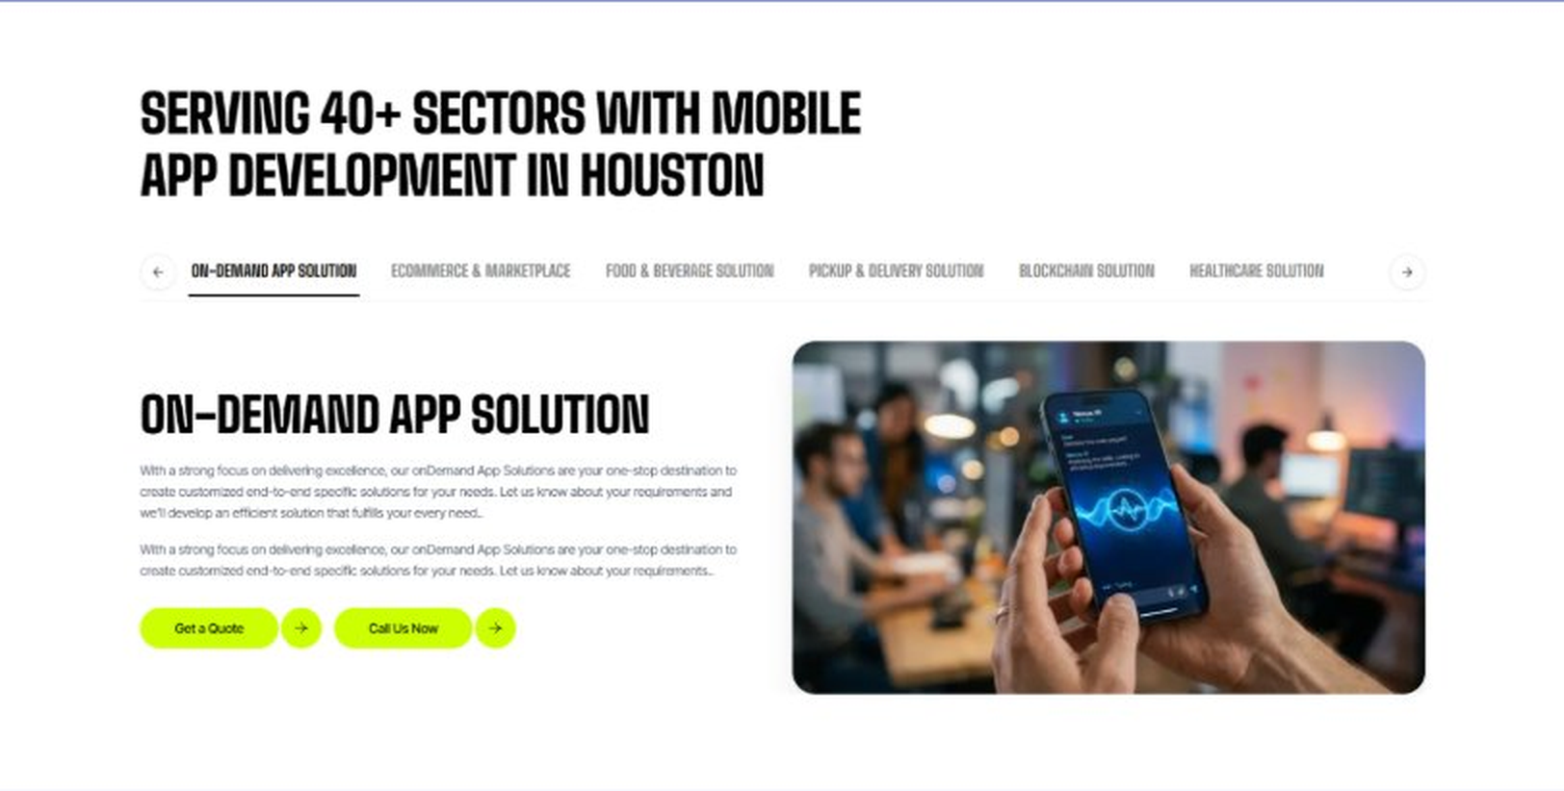
Current live page, www.appsters.io/industry
 | DETAIL
Status | New copy applied
Build Notes | Live block holds 6 sector tabs. New copy holds 5 solutions. Drop one tab or brief a sixth solution.
Copy For This Fold
PAGE ELEMENT | COPY (WORD FOR WORD)
H2 (Section Heading) | Healthcare App Solutions Built For Every Corner Of Care Delivery
Body Copy | Appsters delivers healthcare app development services that cover everything from clinical operations to patient-facing tools. Our systems are architected by senior health app developers who focus on compliance, data accuracy, and stable performance across care settings of every size.
Solution 1 Heading | Healthcare CRM
Solution 1 Copy | Our healthcare CRM tools help practices manage patient relationships, follow-up scheduling, and referral tracking without losing anyone in a spreadsheet.
Solution 2 Heading | Medical Billing Software
Solution 2 Copy | We build medical billing software that reduces claim errors and speeds up reimbursement cycles, integrating cleanly with the payer systems your practice already works with.
Solution 3 Heading | Patient Engagement Software
Solution 3 Copy | Our patient engagement software keeps care plans, reminders, and educational content in one place, built around what actually improves adherence, not just what looks good in a demo.
Solution 4 Heading | Medical Device Integration
Solution 4 Copy | We connect medical devices directly to clinical software, so readings flow into patient records automatically instead of being transcribed by hand.
Solution 5 Heading | Wearable Integration
Solution 5 Copy | Our wearable integration work connects fitness trackers and medical wearables to clinical dashboards, giving providers continuous data instead of a single snapshot at each visit.
Solution 6 Heading | Hospital Management Software
Solution 6 Copy | We build hospital management software that coordinates bed assignments, staff scheduling, and department workflows, cutting down on the coordination gaps that slow hospitals down.
Solution 7 Heading | Healthcare API Integration
Solution 7 Copy | Our healthcare API integration connects EHR systems, labs, and pharmacies into one coherent data flow, so care teams aren't stuck re-entering the same information across five systems.
FOLD 11: Engagement Models Table
Engagement Models Table: Flexible Engagement Models For Any App Development Need
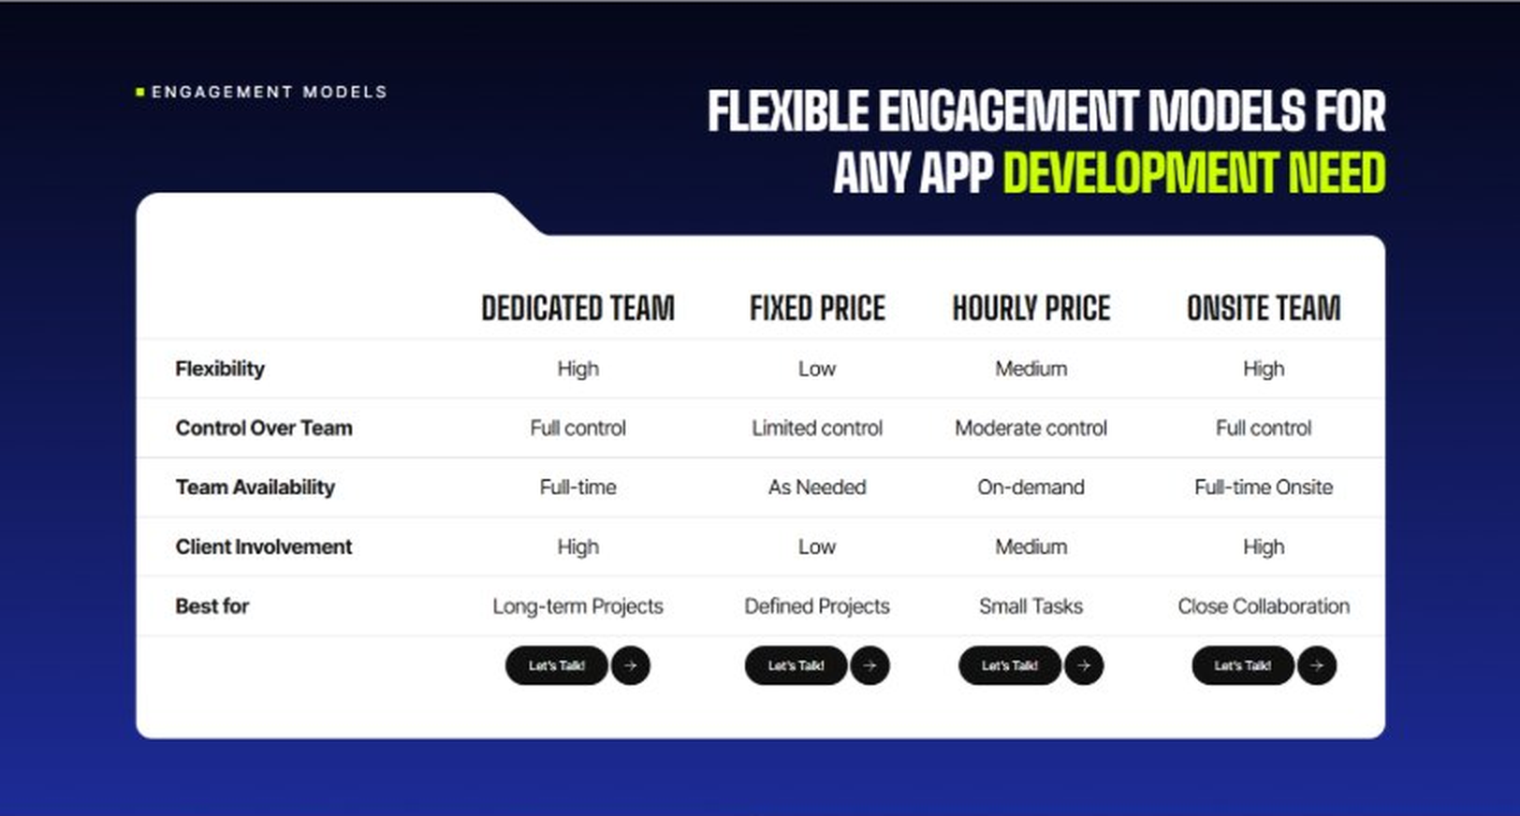
Current live page, www.appsters.io/industry
 | DETAIL
Status | No copy change
Build Notes | No new copy in the source document for this fold. Keep the live block exactly as it is.
FOLD 12: Game App CTA
Game App CTA: Into Engaging Mobile Games
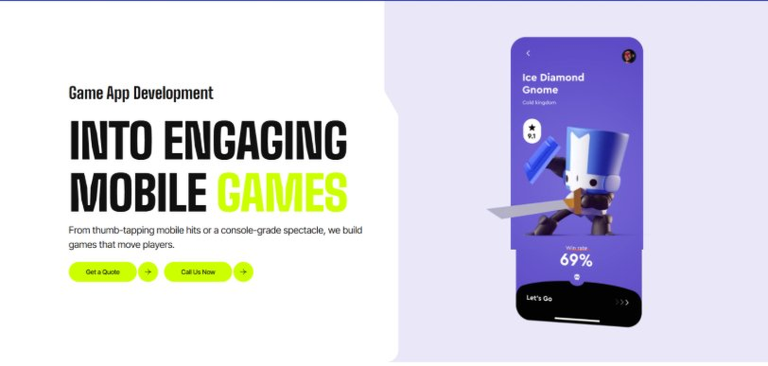
Current live page, www.appsters.io/industry
 | DETAIL
Status | No copy change
Build Notes | No new copy in the source document for this fold. Keep the live block exactly as it is.
FOLD 13: Collaboration And Client Logos
Collaboration And Client Logos
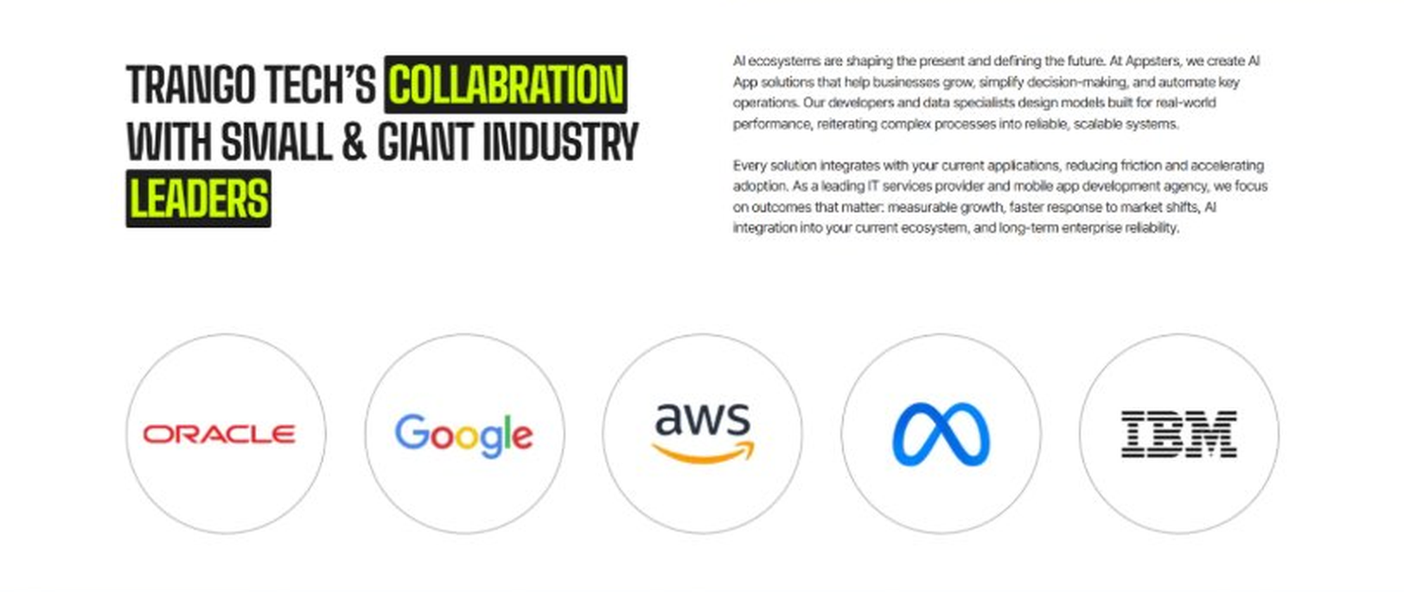
Current live page, www.appsters.io/industry
 | DETAIL
Status | No copy change
Build Notes | No new copy in the source document for this fold. Keep the live block exactly as it is.
QA Flag | Live heading reads "Trango Tech’s Collabration with Small & Giant Industry Leaders". That is a competitor name plus a spelling error sitting live on the page. Fix regardless of this content drop.
FOLD 14: Recognition CTA Banner
Recognition CTA Banner
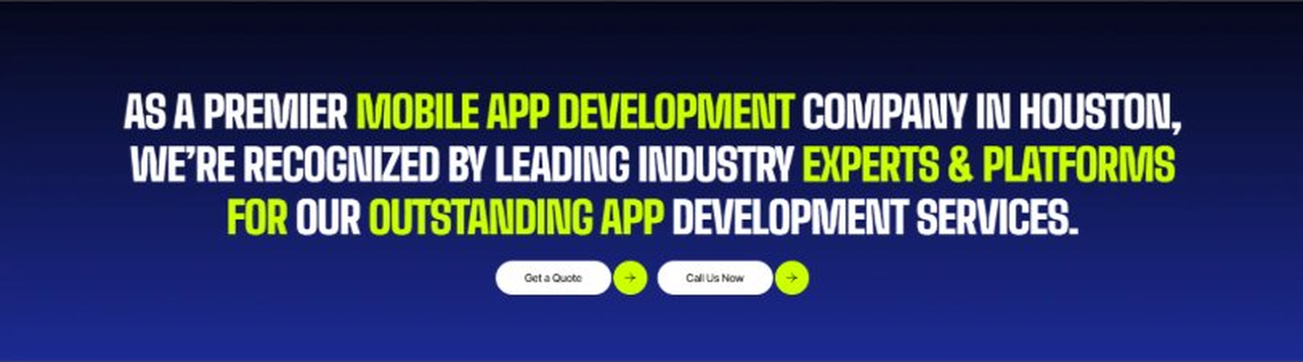
Current live page, www.appsters.io/industry
 | DETAIL
Status | New copy applied
Build Notes | Live block holds a headline and two CTA buttons. New copy supplies the heading and paragraph.
Copy For This Fold
PAGE ELEMENT | COPY (WORD FOR WORD)
H2 (Section Heading) | Patients Are Searching For Care Right Now. Is Your Platform Ready?
Body Copy | Every day you wait is a day another provider gets ahead on patient engagement and care coordination. Let's build a healthcare app that protects patient data and actually improves outcomes. Talk to Appsters today, and let's figure out what your first release actually needs to look like.
FOLD 15: Market Presence And Office Map
Market Presence And Office Map: Expand Your Market Presence
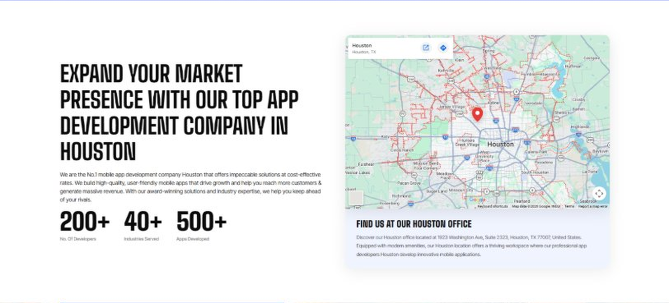
Current live page, www.appsters.io/industry
 | DETAIL
Status | New copy applied
Build Notes | Live block holds a heading, a paragraph, three counters and the office map. New copy supplies the heading and paragraph.
Copy For This Fold
PAGE ELEMENT | COPY (WORD FOR WORD)
H2 (Section Heading) | Healthcare App Developers Who Understand Clinical Reality
Body Copy | As a team that knows how to develop mobile health apps for real clinical environments, we bring compliance rigor and clinical workflow understanding to every build. Our engineers have shipped apps for doctors & patients that hold up under audit, not just demo conditions. Swift, Kotlin, React Native, Node.js, and FHIR/HL7 integrations form our core stack, paired with encryption and access control standards built around actual HIPAA requirements. Where most competitors bolt compliance on at the end, we design it in from the first architecture decision.
FOLD 16: Portfolio
Portfolio: Quick Glimpse On Our Portfolio

Current live page, www.appsters.io/industry
 | DETAIL
Status | New copy applied
Build Notes | Live block holds a heading, a paragraph and one CTA. New copy holds an intro plus 4 named product cards. Source document marks this fold design TBD.
Copy For This Fold
PAGE ELEMENT | COPY (WORD FOR WORD)
H2 (Section Heading) | Healthcare Products Engineered For Real Patient Outcomes
Body Copy | Appsters builds healthcare platforms that behave like long-term clinical infrastructure, not a one-off app store listing. Our solutions stand out because they blend compliance, clinical workflow, and patient behavior data in one stable system. Every product is architected for security, accuracy, and real outcomes.
Product 1 Heading | CareLine
Product 1 Copy | CareLine is a patient engagement app that centralizes appointment scheduling, medication reminders, and secure messaging with care teams. Patients get a single place to manage their care instead of five separate portals for five different providers.
Product 2 Heading | VitalTrack
Product 2 Copy | VitalTrack is a remote monitoring app that syncs with wearable devices to flag abnormal vitals before they become emergencies. Care teams get automated alerts instead of waiting for a scheduled check-in to catch a problem.
Product 3 Heading | TeleVisit
Product 3 Copy | TeleVisit is a telehealth platform built for clinics that needed reliable video consultations without a heavy IT lift. Built-in e-prescribing and visit notes sync directly with existing EHR systems.
Product 4 Heading | RecoverWell
Product 4 Copy | RecoverWell is a post-surgical recovery app that guides patients through recovery milestones, exercise routines, and symptom check-ins, cutting down on unnecessary follow-up calls to the clinic.
Source document note: Portfolio fold, design TBD after content
FOLD 17: Tech Stack Tabs
Tech Stack Tabs: Mobile App Development, A Tech Stack For The Bold
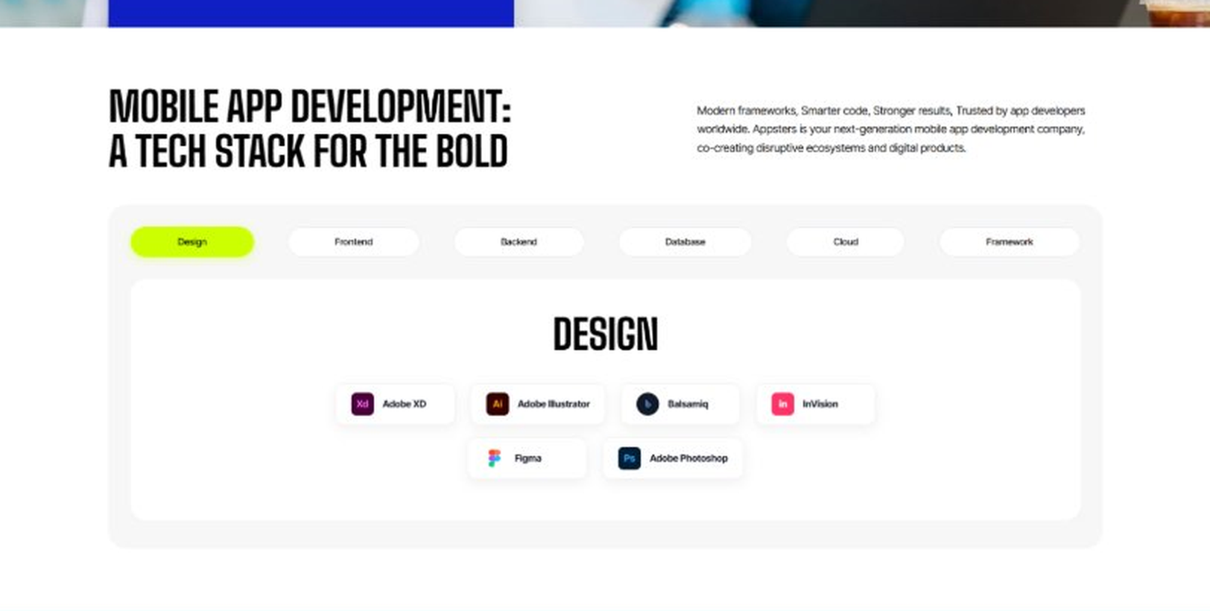
Current live page, www.appsters.io/industry
 | DETAIL
Status | New copy applied
Build Notes | Live block holds 6 category tabs with tool logos. New copy supplies the heading and paragraph, the tab contents stay as they are.
Copy For This Fold
PAGE ELEMENT | COPY (WORD FOR WORD)
H2 (Section Heading) | Technology Stack That Powers High-Performance Healthcare Applications
Body Copy | Our engineering foundation supports secure messaging, clinical data handling, and platform-wide scalability. Through our healthcare application development services, we use Swift, Kotlin, Flutter, React Native, Node.js, Python, FHIR/HL7 integrations, and HIPAA-compliant cloud infrastructure alongside AI-driven clinical support tools. Every stack decision reinforces security, accuracy, and long-term flexibility so your platform can grow without a rebuild.
FOLD 18: Process
Process: App Development Process
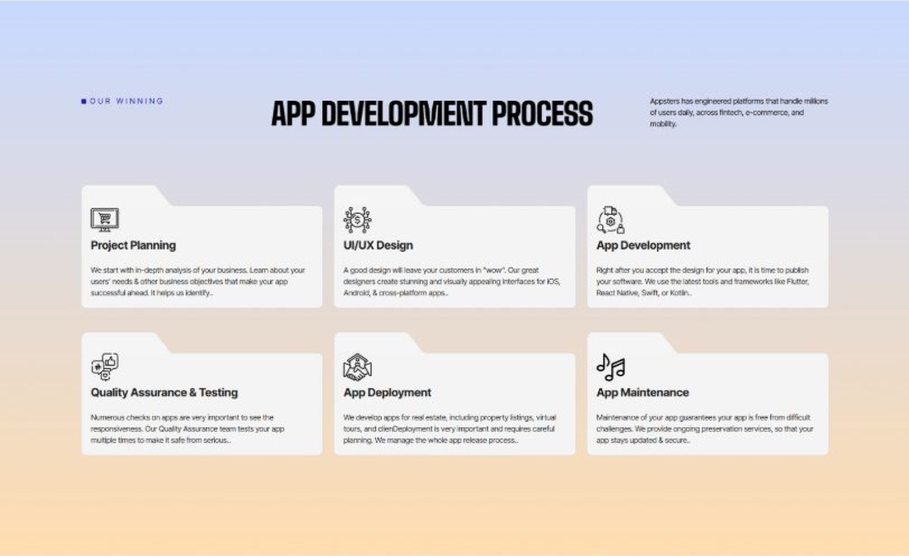
Current live page, www.appsters.io/industry
 | DETAIL
Status | New copy applied
Build Notes | Live block holds 6 step cards. New copy holds 8 steps. Either widen the block to 8 or merge two steps.
Copy For This Fold
PAGE ELEMENT | COPY (WORD FOR WORD)
H2 (Section Heading) | Health Care App Development Process Engineered For Compliance And Trust
Body Copy | A healthcare platform needs more than a clean interface. It needs structure, clarity, and a process engineered for compliance, safety, and clinical accuracy from day one. Our process aligns product goals with technical roadmaps so every phase moves with intention.
Step 1 Heading | App Idea & Research
Step 1 Copy | Every project begins with structured discovery, where our teams map clinical workflows, compliance requirements, and patient behavior. We benchmark existing fitness & wellness mobile apps and define what will actually improve outcomes for your patient population. By the time research closes, the product's purpose, risks, and growth path are already clear.
Step 2 Heading | Strategic Planning & Consultation
Step 2 Copy | Here we translate research into a measurable plan. As a medical app development company, our strategists define the technical architecture, HIPAA healthcare development solutions, and delivery milestones needed from the first sprint.
Step 3 Heading | Wireframing & Prototyping
Step 3 Copy | We turn ideas into tangible user journeys. Wireframes capture patient flows, provider dashboards, and clinical documentation screens in a visual structure stakeholders can react to before a single line of code gets written.
Step 4 Heading | App Development
Step 4 Copy | This is where engineering takes over. Our developers implement secure messaging, on-demand doctor app development features, and clinical data handling with strict attention to compliance at every layer. Development stays sprint-driven and transparent throughout.
Step 5 Heading | Expert QA & Testing
Step 5 Copy | Quality assurance covers far more than bug hunting. We validate data security, HIPAA compliance, cross-device behavior, and clinical workflow accuracy. Only stable, predictable behavior earns approval to move forward.
Step 6 Heading | App Launch
Step 6 Copy | Launch is a coordinated rollout, not a leap of faith. We manage store compliance, security documentation, and final performance checks so your platform enters the market ready for real patient traffic.
Step 7 Heading | Deployment
Step 7 Copy | Our deployment pipelines are built for consistency and safety. We configure HIPAA-compliant cloud infrastructure and calibrate autoscaling so fitness & wellness mobile apps and clinical tools alike perform reliably at scale.
Step 8 Heading | Maintenance & Support
Step 8 Copy | Post-launch, we keep monitoring security posture, refining clinical workflows, patching vulnerabilities, and responding to new regulatory or app store requirements, so your healthcare apps keep improving long after day one.
Source document note: Process fold, design TBD after content
FOLD 19: Blog Posts
Blog Posts: Our Related Blog Posts
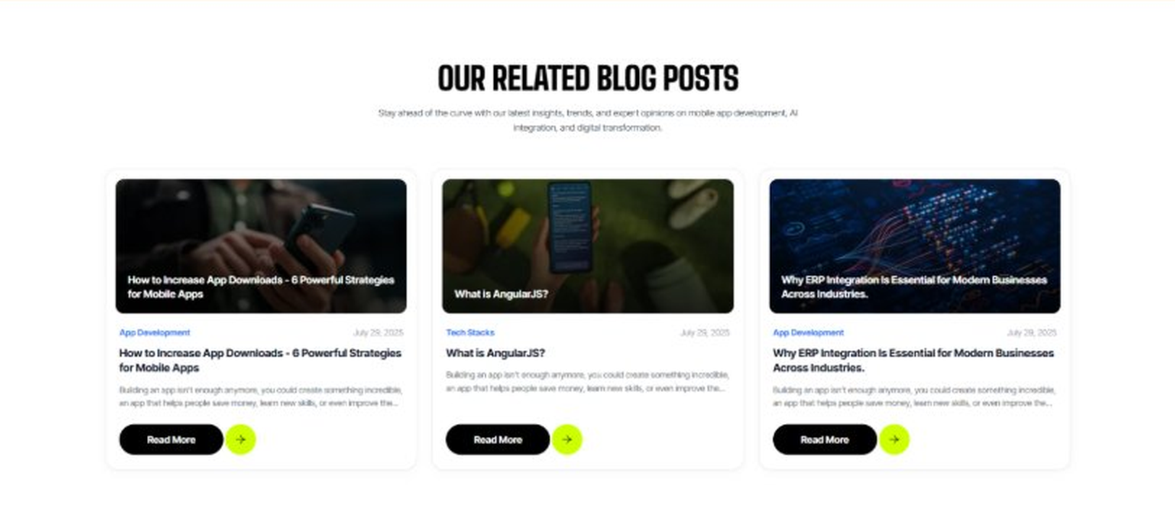
Current live page, www.appsters.io/industry
 | DETAIL
Status | No copy change
Build Notes | No new copy in the source document for this fold. Keep the live block exactly as it is.
FOLD 20: FAQs
FAQs: Your Questions, Our Clarity
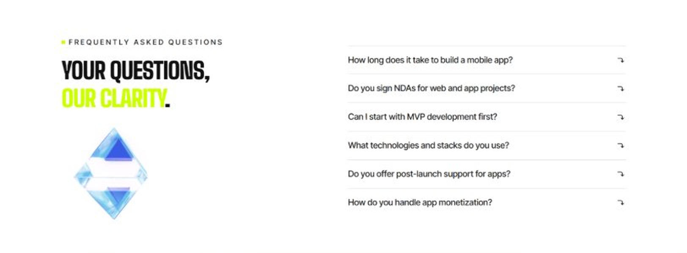
Current live page, www.appsters.io/industry
 | DETAIL
Status | New copy applied
Build Notes | Live block holds 6 accordion rows. New copy holds 6 questions and answers. Clean one to one fit.
Copy For This Fold
PAGE ELEMENT | COPY (WORD FOR WORD)
H2 (Section Heading) | Frequently Asked Questions
FAQ 1 Question | How long does it typically take to build a fully functional healthcare app?
FAQ 1 Answer | Timelines depend on compliance scope, clinical integrations, and feature complexity. Most projects take 12 to 20 weeks for a stable release, including design, engineering, QA, and pilot testing. As a healthcare app development company, we provide clear milestones from day one.
FAQ 2 Question | Can Appsters build a medical app with telehealth and on-demand doctor app development features?
FAQ 2 Answer | Yes. We build medical apps with secure video consultation, e-prescribing, and on-demand doctor app development features baked into the core architecture, not added as an afterthought.
FAQ 3 Question | Do you build fitness app development company-style wellness features into healthcare apps?
FAQ 3 Answer | Absolutely. Many of our healthcare app development projects include wellness app features like activity tracking and coaching alongside clinical tools, when that fits the patient population.
FAQ 4 Question | What makes Appsters different from other healthcare mobile app development company options?
FAQ 4 Answer | We treat HIPAA compliance, clinical workflow accuracy, and data security as core product decisions, not add-ons. Most companies offering healthcare application development services focus on UI first and compliance later. We do both from the start.
FAQ 5 Question | Can you connect our app to existing EHR and lab systems?
FAQ 5 Answer | Yes. Our mobile health app development experience includes deep work with FHIR and HL7 standards, so integration with existing clinical systems rarely starts from zero.
FAQ 6 Question | What ongoing support do you provide to patients for medical apps after launch?
FAQ 6 Answer | Our support includes post-launch monitoring, compliance checks, feature updates, and infrastructure scaling, so your healthcare apps keep improving long after release.
FOLD 21: Locations
Locations: Our Global Presence
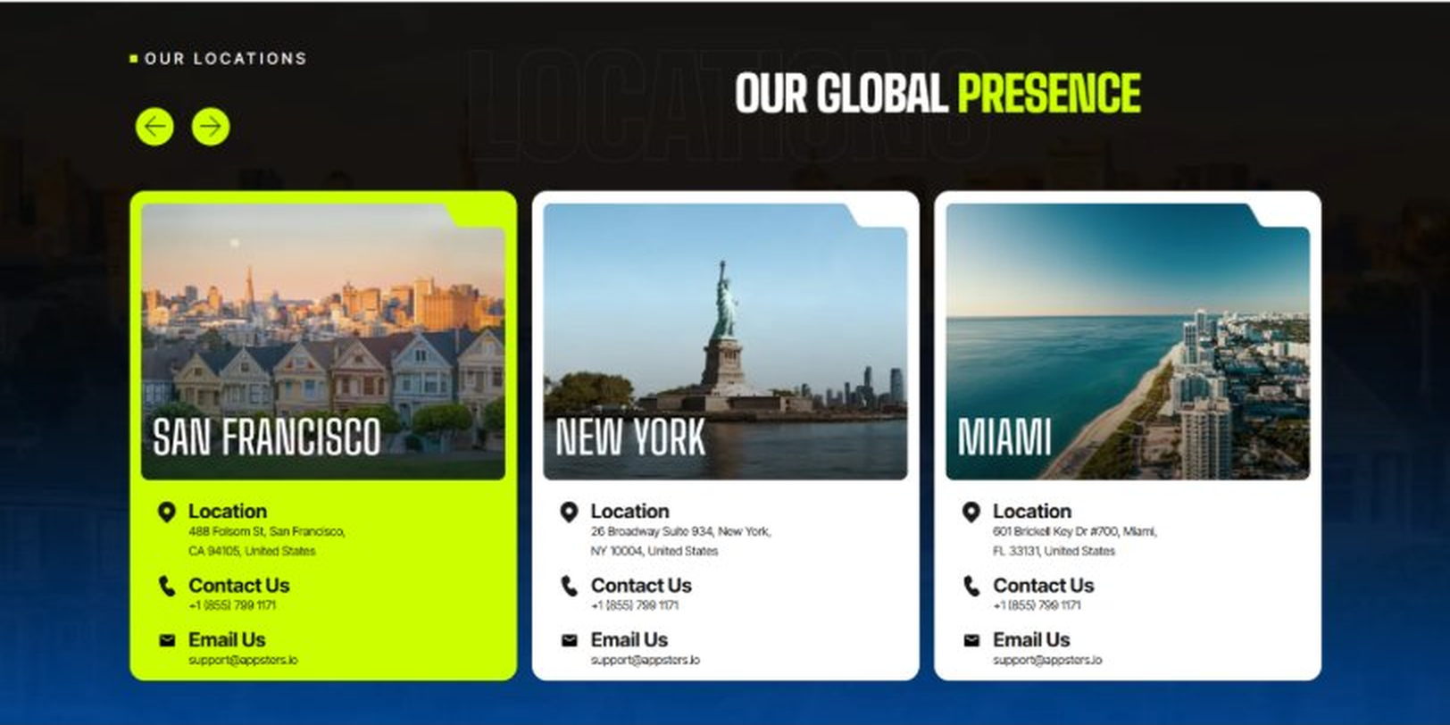
Current live page, www.appsters.io/industry
 | DETAIL
Status | No copy change
Build Notes | No new copy in the source document for this fold. Keep the live block exactly as it is.
FOLD 22: Contact Form
Contact Form: Connect With Us
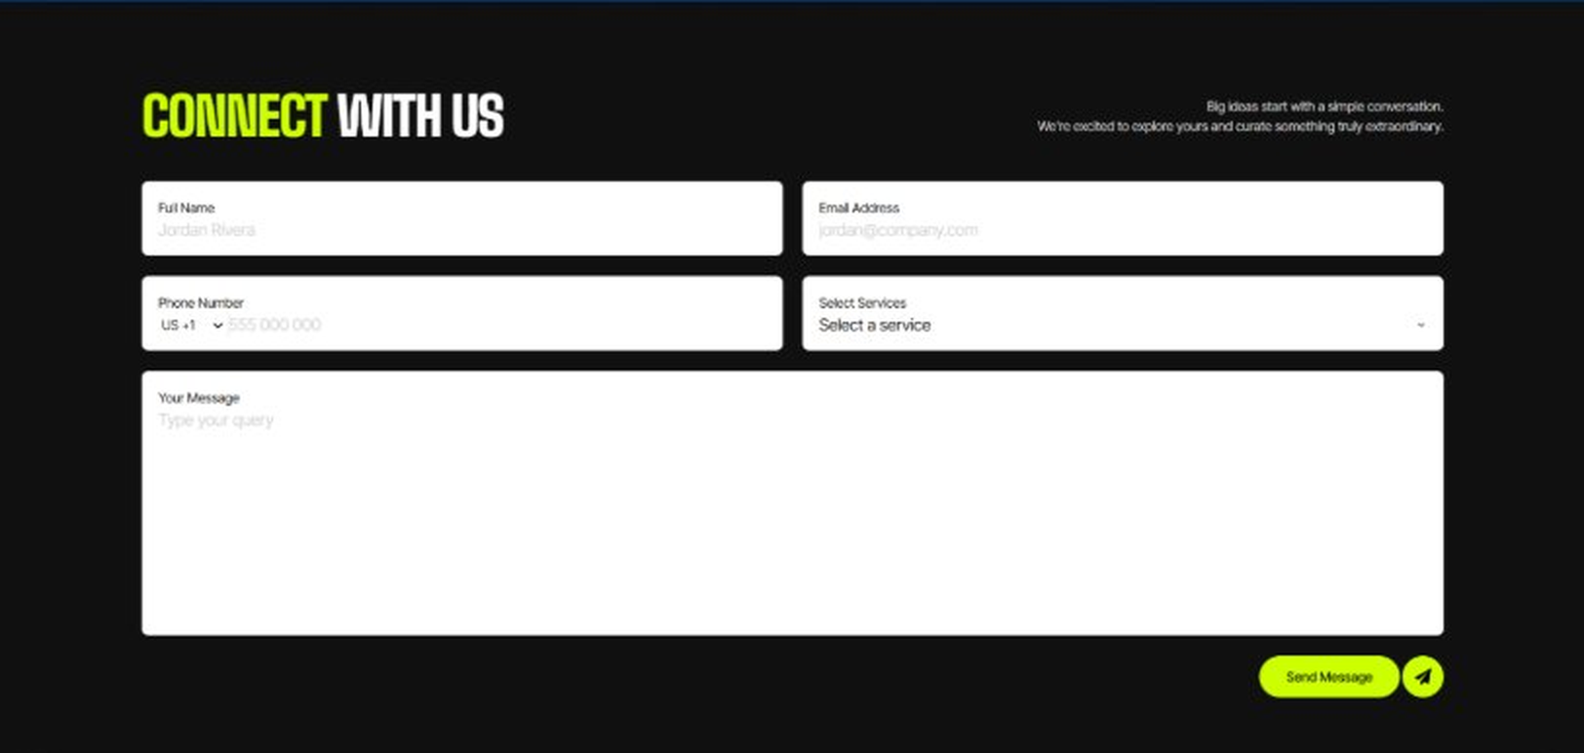
Current live page, www.appsters.io/industry
 | DETAIL
Status | No copy change
Build Notes | No new copy in the source document for this fold. Keep the live block exactly as it is.
FOLD 23: Footer
Footer
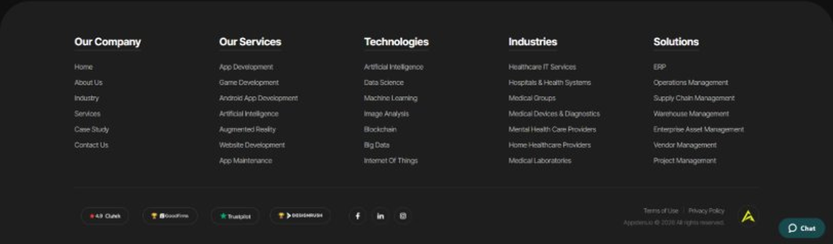
Current live page, www.appsters.io/industry
 | DETAIL
Status | No copy change
Build Notes | No new copy in the source document for this fold. Keep the live block exactly as it is.
NEW BLOCKS REQUIRED
The three blocks below are in the source content but have no matching section anywhere on the current /industry page. Each one needs a new block built.
NEW BLOCK: A Healthcare App Company That Takes Regulatory Compliance Seriously
 | DETAIL
Status | No equivalent block on the live page
Placement | Suggested placement: directly after Fold 5, reusing the services card grid styling.
Copy For This Block
PAGE ELEMENT | COPY (WORD FOR WORD)
H2 (Section Heading) | A Healthcare App Company That Takes Regulatory Compliance Seriously
Feature 1 Heading | HIPAA
Feature 1 Copy | Every system we build treats patient data protection as a first-class requirement, not a checkbox added before launch.
Feature 2 Heading | GDPR
Feature 2 Copy | For platforms serving patients across borders, we design data handling that meets GDPR's stricter consent and portability requirements.
Feature 3 Heading | FDA
Feature 3 Copy | For apps that cross into regulated medical device territory, we build with FDA submission requirements in mind from the earliest architecture decisions.
Feature 4 Heading | HITECH
Feature 4 Copy | We implement the breach notification and security standards HITECH requires, so a data incident doesn't turn into a compliance crisis.
Feature 5 Heading | SaMD
Feature 5 Copy | For software that qualifies as a medical device in its own right, we build with SaMD classification and validation requirements baked into the development process.
NEW BLOCK: Industries We Serve
 | DETAIL
Status | No equivalent block on the live page
Placement | Suggested placement: directly after Fold 10, as a card grid rather than tabs.
Copy For This Block
PAGE ELEMENT | COPY (WORD FOR WORD)
H2 (Section Heading) | Industries We Serve
Body Copy | One Codebase. Infinite Industries. Our web, app, and AI solutions are built to perform, scale, and adapt while setting industry standards and redefining what's possible for businesses everywhere.
Industry 1 Heading | Fintech
Industry 1 Copy | We co-create secure, compliant fintech apps that simplify payments, investments, and trading, applying the same rigorous data security standards we use in HIPAA-compliant apps.
Industry 2 Heading | Education
Industry 2 Copy | Our education apps gamify learning and power virtual classrooms, borrowing the same patient engagement mechanics we use to improve medication adherence.
Industry 3 Heading | Real Estate
Industry 3 Copy | We design real estate apps that help buyers, sellers, and agents close deals faster, using the same secure document handling we build for clinical records.
Industry 4 Heading | Automotive
Industry 4 Copy | From fleet dashboards to car rental apps, we digitize automotive operations using the same real-time monitoring expertise behind our remote patient monitoring tools.
Industry 5 Heading | Music
Industry 5 Copy | We create streaming apps and artist marketplaces, applying the same accessibility standards we build into patient-facing healthcare apps.
Industry 6 Heading | Social Media
Industry 6 Copy | We build social platforms that are scalable and sticky, drawing on the same secure messaging infrastructure we use for provider and patient communication.
Industry 7 Heading | Logistics
Industry 7 Copy | We power logistics apps with route optimization and real-time tracking, using the same infrastructure behind our medical supply and cold-chain tracking tools.
Industry 8 Heading | Ecommerce
Industry 8 Copy | We build ecommerce apps with frictionless checkouts and AI product recommendations, backed by the same secure payment infrastructure we use for patient billing.
NEW BLOCK: Advanced Technologies That Power Our Healthcare Apps
 | DETAIL
Status | No equivalent block on the live page
Placement | Suggested placement: directly after Fold 17, reusing the services card grid styling.
Copy For This Block
PAGE ELEMENT | COPY (WORD FOR WORD)
H2 (Section Heading) | Advanced Technologies That Power Our Healthcare Apps
Body Copy | As a healthcare app development company built around what's next, we don't stop at scheduling and messaging. Every healthcare app developer on our team stays current with tools that keep platforms competitive, from AI diagnostics support to voice interfaces. Unlike most healthcare app development companies still catching up on basic medical app development, we're already building AI-based health apps that connect directly to patient & doctor mobile apps and, where relevant, the wearable ecosystems our fitness app developers specialize in.
Technology 1 Heading | AI Integrated Health Apps
Technology 1 Copy | We build AI Integrated Health Apps with symptom triage support, risk flagging, and automated documentation assistance, giving care teams more time for actual patients.
Technology 2 Heading | Wearable Integration
Technology 2 Copy | Our wearable integration connects continuous health data to clinical dashboards, extending visibility well beyond a single office visit.
Technology 3 Heading | Cloud Solutions
Technology 3 Copy | Our cloud solutions keep healthcare platforms fast and reliable, with HIPAA-compliant autoscaling infrastructure built to handle demand spikes safely.
Technology 4 Heading | Voice Technology
Technology 4 Copy | We build voice-enabled documentation and patient interaction tools that cut down on manual data entry for busy care teams.
Technology 5 Heading | API Integration
Technology 5 Copy | We connect your platform to EHR systems, labs, and pharmacy networks through clean, well-documented API integration.

